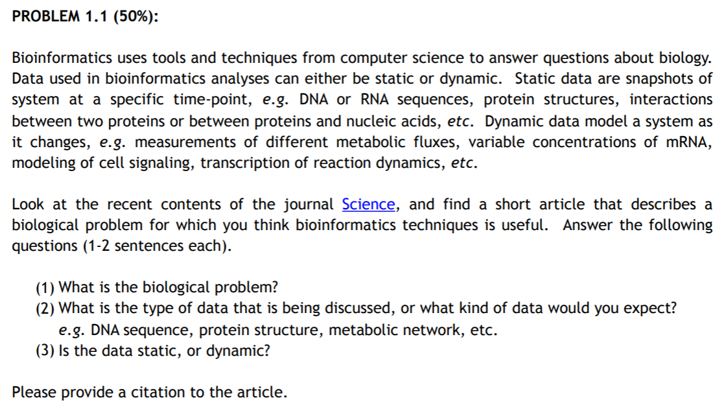

Article link: <http://advances.sciencemag.org/content/4/8/eaat3007>

1. The biological problem in the article is related to molecular structure of DNA. The main challenge in DNA quadruplex design is to encode a three-dimensional structure into the primary sequence, despite its multiple, repetitive guanine segments. The author identifies and detail structural elements describing all 14 feasible canonical quadruple scaffolds and demonstrate their use in design and control. This works outlines the new roadmap for implementation of targeted design of quadruplexes for material, biotechnological, and therapeutic applications.
2. Protein Structure
3. Static data

**PROBLEM 1.2**

Daily activity- making your favourite food-Noodles

1. Wash vegetables
2. Cut Tomato, Onion, Shimla Mirch, Peas, Green Chilly, Garlic in separate bowl
3. Open noodles packet and boil them for few minutes
4. Wash noodles in running water
5. Put oil on noodles so that they do not stick together
6. Add oil to pan
7. Add vegetables
8. Add noodles
9. Add sauces
10. Add salt
11. Mix all ingredients
12. Cook for 10-15 min
13. Noodles are ready to eat

**PROBLEM 1.3**

#initialize the count to 0

count = 0

grt=0

#loop through each nucleotide in the mRNA sequence

for every nucleotide in mRNA_sequence:

if (nucleotide is ‘A’):

count = count + 1

if (nucleotide !=’A’):

count =0

if (count>grt):

grt=count

print(grt)

#report result